s1739768

**DAH Checkpoint 2 Document**

***1. Explain what all connections to the ADC chip are for (do not simply copy information from the datasheet — explain the practical purpose of these connections).***

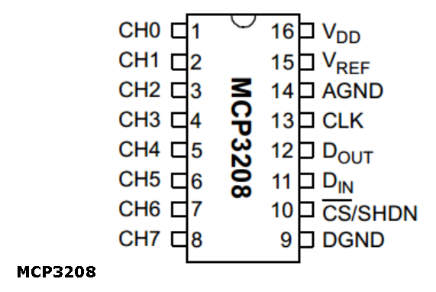

* Pins 1-8 (CH0-CH7) are 8 individual analogue input channels to read in analogue voltages at a point between a potential divider for example.
* Pin 16 (VDD) is the connection to a power supply between +2.7V to 5.5V to power the ADC
* Pin 15 (VREF) connects with a reference voltage to assign the highest binary output (4095) to, so is important to be accurate and consistent so that the conversions are accurate
* Pin 14 (AGND) is the analogue ground connection, to ground internal analogue circuitry
* Pin 13 (CLK) is the clock pin which synchronises both sides of data being sent and received so the receiver reads the bits when each bit is steady and valid
* Pin 12 (DOUT) is the SPI serial data output pin and delivers the converted data bits serially
* Pin 11 (DIN) is the SPI serial data input pin where instructions are received
* Pin 10 (CS/SHDN) is the chip select/shutdown pin and when it is set high, makes all other pins ignore changes sent to them allowing them to remain connected but not be in use, allows device to left in ‘standby’ mode which saves energy
* Pin 9 (DGND) is the digital ground connection, to ground internal digital circuitry, separate circuitry for analogue and digital to make sure they don’t interfere

***2. Explain the meaning of the return values of each Python method for the ADC.***

* ADC0. analogCount () returns the number of analogue channels (8 for MCP3208)
* ADC0. analogResolution () returns the analogue resolution/bit count (12 for MCP3208)
* ADC0. analogMaximum () returns the maximum analogue integer value for converting a voltage input to binary number based on reference voltage (4095 for MCP3208)
* ADC0. analogReference () returns the voltage corresponding to the maximum analogue integer (reference voltage)
* ADC0. analogRead ( channel ) returns the integer value of the given analogue channel as converted from the voltage (see next question)
* ADC0. analogReadFloat ( channel ) returns the float value of the given analogue channel (the integer value over the maximum 4095)
* ADC0. analogReadVolt ( channel ) returns the voltage value of the given analogue
* ADC0. analogReadAll () returns a list of all channels’ integer values
* ADC0. analogReadAllFloat () returns a list of all channels’ float values
* ADC0. analogReadAllVolt () returns a list of all channels’ voltages

***3. What is the primary (most fundamental) ADC output and how is the final voltage output calculated from this?***

The ADC outputs an integer from 0 to 212 -1= 4095 for 12-bit MCP3208 from the voltage it reads in based on the following calculation:

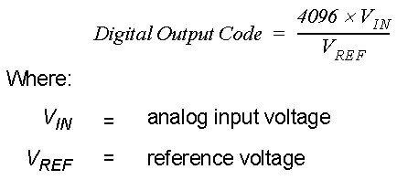

Noting that VIN can vary from 0V to VREF minus one least significant bit voltage

It returns an integer which is in the same ratio to 4095 as the voltage read in is to the reference voltage.

***4. Explain how the ADC readings change when you cover the LDR with your hand— you may need to provide a circuit diagram.***

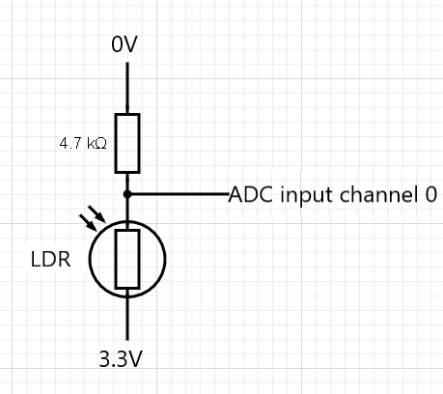

Resistance of LRD increases as the light intensity hitting it drops (from being covered by hand). The LDR is in a potential divider circuit with the resistor. The current decreases due to the increase in total resistance of both components in series added. The voltage across the resistor decreases as its resistance is unchanged. This is read by the ADC channel 0 as the other side of the resistor is connected to ground so the ADC reading decreases.

***5. Explain what all the connections to the DAC chip are for.***

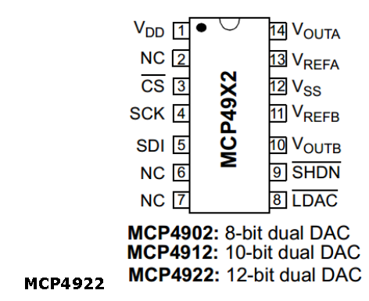

* Pin 1 (VDD) is the connection to a power supply between +2.7V to 5.5V to power the DAC
* Pin 2 (NC) is no connection
* Pin 3 (CS) is the chip select pin and when low the device listens to data in. CS’s on both devices allows each device to only receive intended information from the same SPI bus
* Pin 4 (SCK) is the serial clock input which synchronises both sides of data being sent and received so the receiver the receiver reads the bits when each bit is steady and valid
* Pin 5 (SDI) is the serial data input pin where DAC receives instructions and values
* Pin 6 (NC) is no connection
* Pin 7 (NC) is no connection
* Pin 14 (VOUTA) is the DAC A output pin and can drive an analogue voltage from VSS to VDD
* Pin 13 (VREFA) is the voltage reference input for DAC channel A used in the conversion calculation so is important to be accurate and consistent
* Pin 12 (VSS) is the DAC ground pin and signal current return pin
* Pin 11 (VREFB) is the voltage reference input for DAC channel B used in the conversion calculation so is important to be accurate and consistent
* Pin 10 (VOUTB) is the DAC B output pin and can drive an analogue voltage from VSS to VDD
* Pin 9 (nSHDN) shuts down the DAC channels when set to low so VOUTA and VOUTB no longer driven
* Pin 8 (nLDAC) is the latch DAC input pin and an alternative way to update the outputs VOUTA and VOUTB